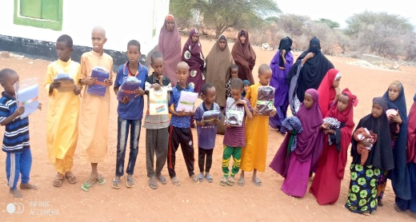

VISON COMMUNITY DEVELOPMENT ORGANIZATION

VISION COMMUNITY

ORGANIZATION

PROJEC PROFILE

VISON COMMUNITY DEVELOPMENT ORGANIZATION

(VICDO)

TEL NO: 0726251674/0723569912

E-MAIL:vicdowajir@gmail.com

**VISON COMMUNITY DEVELOPMENT ORGANIZATION (VICDO)**

**NAME: VISON COMMUNITY DEVELOPMENT ORGANIZATION (VICDO)**

**DATE OF FORMATION: 10/05/21**

**DATE OF REGISTRATION: 16/06/21**

**BACKGROUND INFORMATION**

Vision Community Development Organization (VICDO) Is a community based organization, Non-project and non-Government initiated in June 2021 to help Spearhead community driven development initiative and enable needy community groups participate in integrated activities to achieve quality livelihood and be self-sustainable. VICDO delivery its activities through the power and spirits of volunteerism approach to build sustainable community intercultural exchanges among and thriving villages in our country.

Our main purpose is promote youth employment and information exchanges among Kenyans and international communities (voluntary Work-camps, short and long term volunteering youth mobility, social inclusions, Sports and physical activities community development, promotion , of peace among our diverse communities understanding and unity of purpose.

VICDO provides services in entrepreneurship and development information technology training and empowerment (ICT).education, health in HIV/AIDS management and awareness, malaria and TB awareness and advocacy Rehabilitation of streets children, Supports Orphans, and vulnerable children capacity building sessions to youth groups vocational schools, organic farming and agricultural activities, Environmental education and management

VICDO harness and develop the power of power of young people by effectively involving them in direct implementation of the core activities that develops their skills enabling them become self-enhance and sustainable people in community service and development. We engaged young people in a constructive manner enabling them initiate and build their ideas +develop prototype test and develop products that meet the people’s needs and help reduce the problems and changes that most faced in development sector

The vision of the community development organization (VICDO) is based in Wajir county, northeastern Kenya.

**Vision**

**Mission**

Our mission is to improve the quality of life of the local communities through sustainable local development initiatives in Kenya.

**Core Values**

1. People are at the very centre and heart of developments they are the forces behind all will do and every endeavor we undertake.
2. Transparency and accountability drives over actions.
3. sustainability is built into every intervention we pursue
4. A holistic approach is essential to our treatment of ourselves and one another.

**Goals**

Our goals is to support the local children youths and women through capacity building activities to achieve knowledge, skills, networks and motivation that will make them aim to have an improved acceptable living standard and gain human dignity and self-esteem.

**Objectives**

1. Empowering the community groups through micro-finance development through saving and loaning.
2. Support of orphans and vulnerable children.
3. To establish VICDO’s own long- term and self-sustaining income generating projects to support organization activities.
4. to enhance productive live hood and well-being for people living with HIV/AIDS and their families
5. To assist community group members in an effort to mobilize and enhance income generating activities and this improve the communal asset base.
6. To develop eco-tourism and environmental management activities in the region as a source of revenue for people of people in the village.
7. To involves ourselves in the social environment of youth (orphans) through community events such as capacity, building, youth training and social activities which brings our youths and community together.

**Area of operation**

We operate in Wajir county and its environs

**Target Group**

The primary target of the VICDO is orphans, vulnerable children, and people living with HIV/AIDS, people with disabilities, widows, youths and women to live Wajir county sub-counties and with its township. The target group is very important it’s expected that significant changes, learning and developments will take place for our target group and have access to basic needs, education, health care, protection and a sense of belonging to the society.

**Achievements**

* Establishment of VICDO website that serves a platform for projects publicity and promotion to the entire world.
* Supporting ten (10) orphans with uniform and vulnerable children to continue with their education.
* partnering with government in environment activities and initiatives aimed at achieving environmental sustainability such as tree planting at Athibohol dispensary
* VICDO also participated various programs and activities through town administrations of different villages includes clean-ups, tree planting, cabbage collection, and training on capacity building.

**Collaborative and partnership**

* The organization partners with ministry of social service through social development approaches in Wajir County and ministry of environment and natural resource at national level.

**Future Plans**

* construction of VIDCO community resource centre which will provide the projects target youth population which structured career development information, skills and opportunities to get jobs, start own business or transition into higher education.
* Establishment of permaculture and ecological farming demonstration plots for exchange learning.

**Need Support**

* Linkage and collaboration to development partners
* Linkage to online platform to enable projects implementation with other local and international development organization.
* Financial support for projects implementation and community development pillars enhancement.

**Distribution of clothes to orphans and vulnerable children during Eid-ul adha**

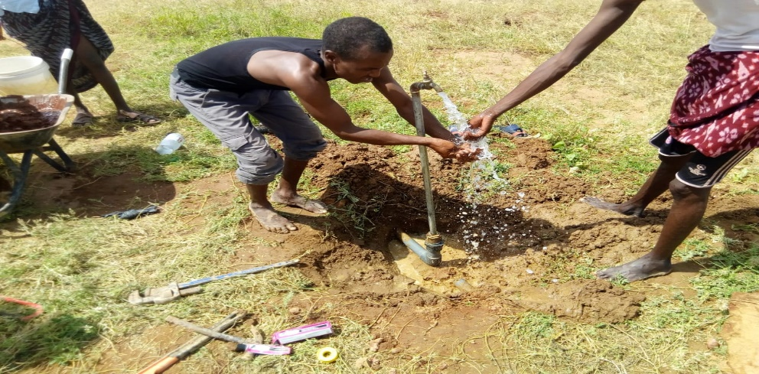

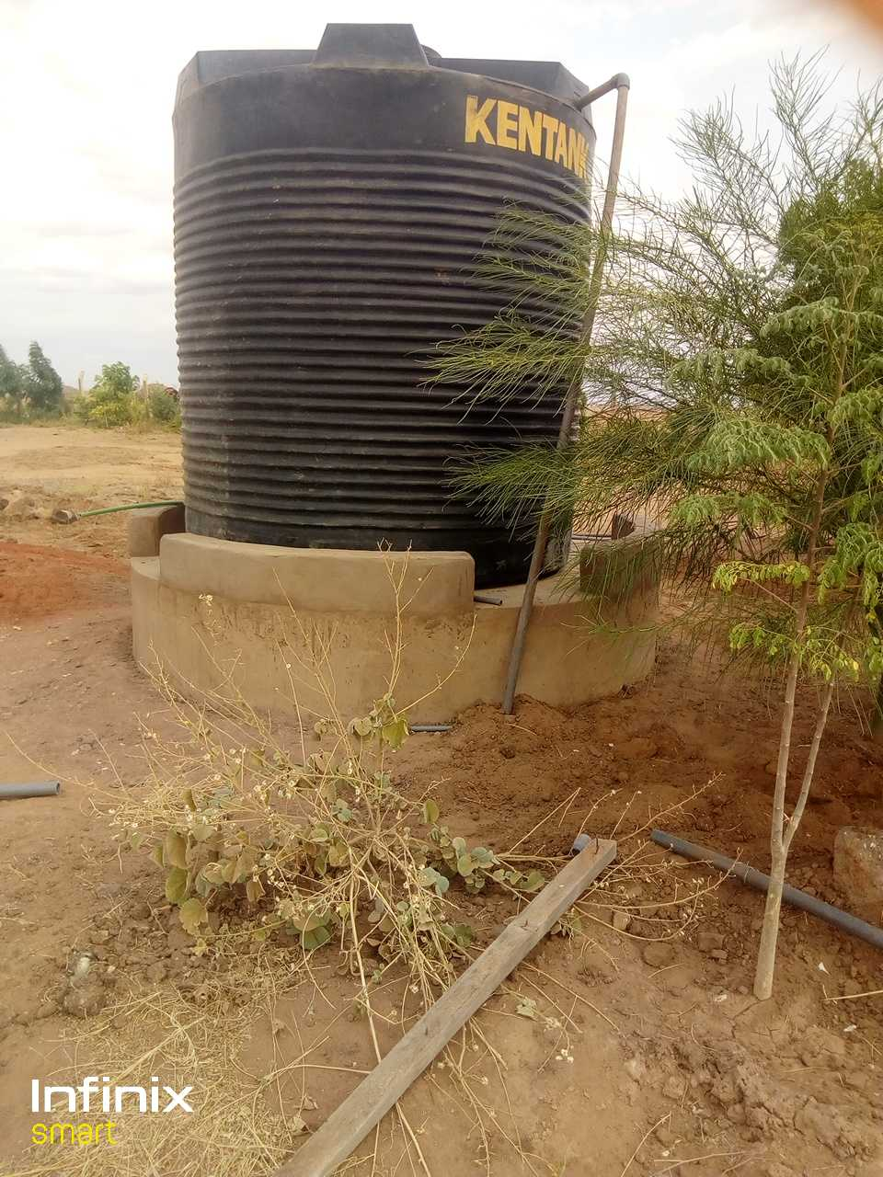

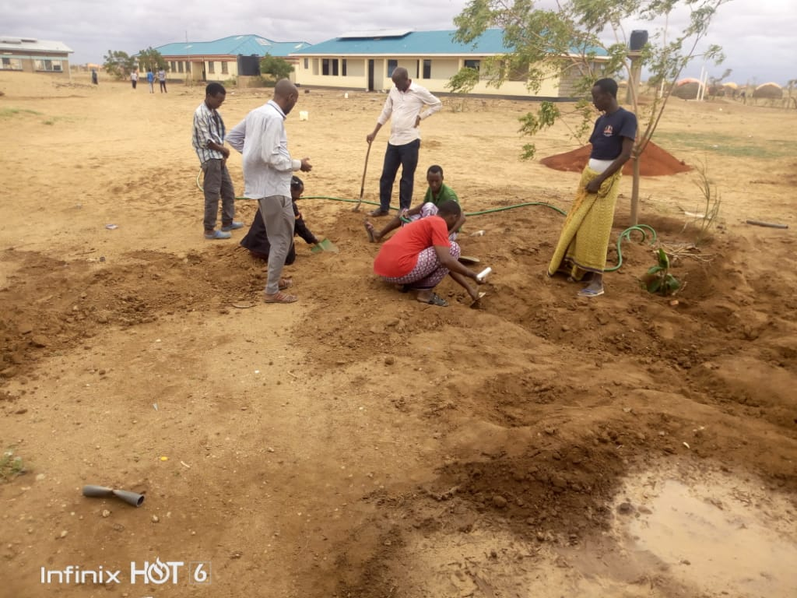

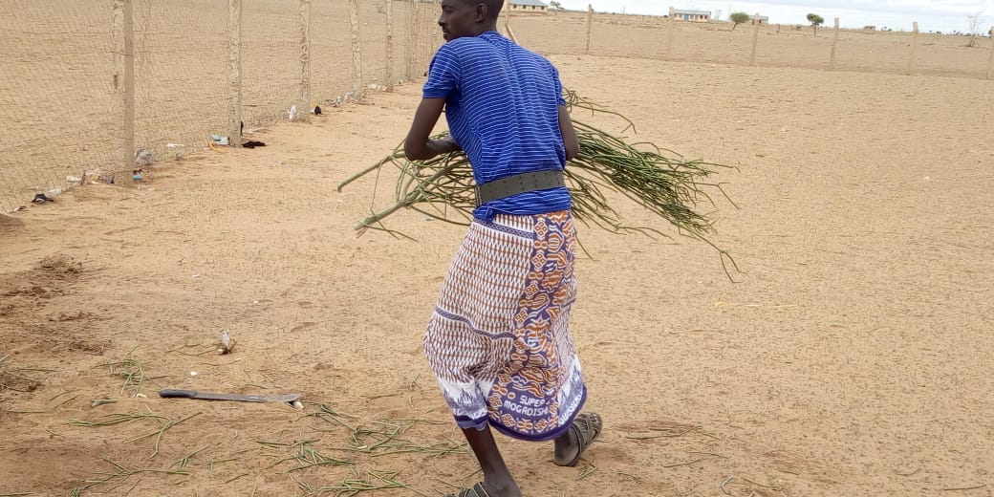

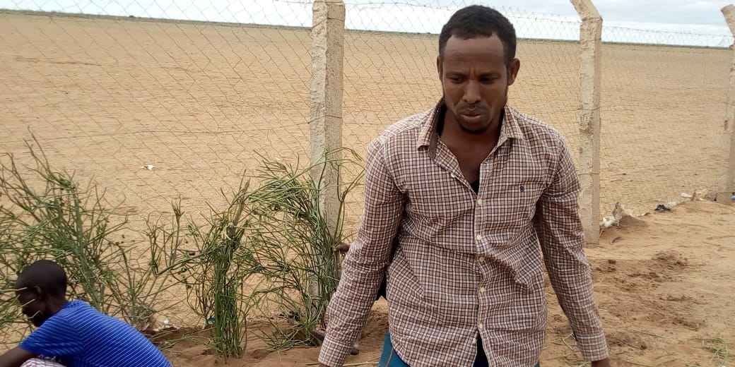

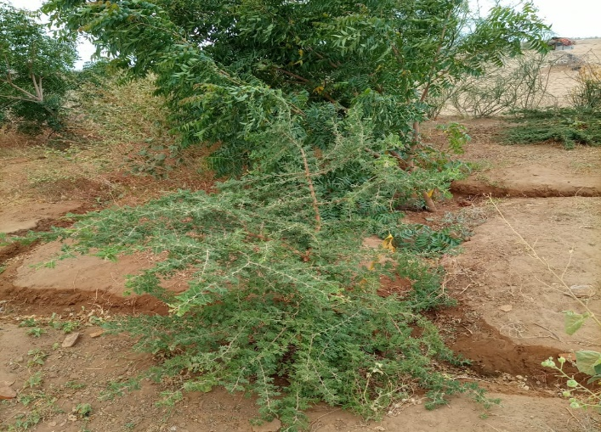

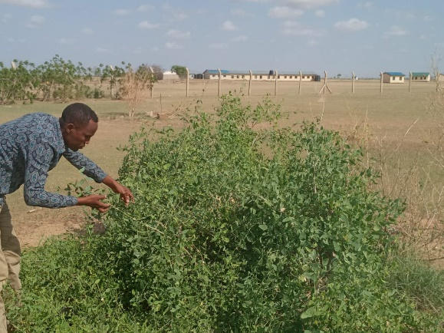

**Tree planting at Athibohol Dispensary**

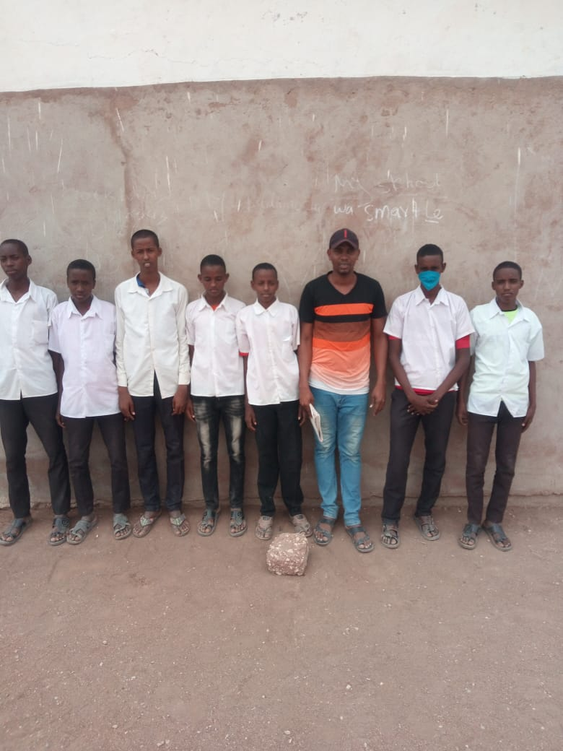

**Distribution of uniforms to orphans and vulnerable children**

**At Athibohol primary**